Descriptive Statistics of the Dataset

Data Cleaning & Preparation:

Firstly, we had to clean the dataset. There were a few inconsistencies and missing/impossible values, such as, Nikhil Kapoor’s & Meera Gupta’s ages are -6 and 999. Minus 6 is an impossible value and 999 is an outlier since the highest human age of the dataset is 72 (Rohan Kapoor). Then we had to replace some values, which are from age 1-4 and because we considered them too young to do shopping and replaced them with NA/Null. Also, we replaced aged 150 people with 15 because it might be a registry entry error of the extra ‘0’. There was some rows that only had age values but no other entries, so we removed them from the dataset. Average age of the whole cleaned dataset is 34 (rounded for 34.395). We replaced all the missing values with the average value. For this cleaning part, we used “dplyr” library and it’s functions in R. For, plotting graphs, we used ggplot function.
After the cleaning part, we separated the dataset into 3 parts according to age: 72/3= 24. So, from age 5-24 will be considered as Young, 25-48 will be considered as Middle Aged and 49-72 will be considered as Old. Doing this, we get 809 people aged as ‘Young’, 3010 people as ‘Middle Aged’ and 491 people as ‘Old’. It is done to determine the measurements of the quantity amount and unit price – whether they tend to spend more or less, whether there is a relation between age and spending amount.
Secondly, there are missing values in the quantity column, but there are unit prices, so we can conclude that the individuals brought some products, but the missing values are data entry errors. The range is from 1-10 (removing outliers 999), So in this case, we replaced them with the mean value 7 (rounded from 7.379).

Implemented R codes:

# Loading the dataset first
dataset <- read.csv("retail_sales_dataset.csv", header = TRUE)

# Remove invalid age and quantity codes 999 and -6 an replace with NA
dataset <- dataset %>% mutate( age = ifelse((age >= -7 & age <= 4) | age == 999, NA, age) )
# Replacing ages 150 with 15
library(dplyr)
dataset <- dataset %>%
mutate(
age = ifelse(age == 150, 15, age)
)
# Naming the range limits as variables
young_min <- 5
young_max <- 24
middle_min <- 25
middle_max <- 48
old_min <- 49
old_max <- 72

library(dplyr)

dataset <- dataset %>%
mutate(
age_group = case_when(
age >= young_min & age <= young_max ~ "Young",
age >= middle_min & age <= middle_max ~ "Middle Aged",
age >= old_min & age <= old_max ~ "Old",
TRUE ~ NA_character_
)
)
young_range <- "5-24"
middle_range <- "25-48"
old_range <- "49-72"
table(dataset$age_group)
Young_MiddleAged_Old = c(809,3010,491)

# Changing the missing values and 999 from quantity
dataset$quantity[dataset$quantity == 999] <- 7
dataset$quantity[is.na(dataset$quantity)] <- 7
# Summary
summary(data$Age)

#plots
#1.Pie Chart for Age Group
library(dplyr)
library(ggplot2)

# Count people in each age_group
age_counts <- dataset %>%
count(age_group)
age_counts
ggplot(age_counts, aes(x = "", y = n, fill = age_group)) +
geom_col(width = 1) +
coord_polar(theta = "y") +
labs(
title = " Age Group Distribution",
fill = "Age Group"
) +
theme_void()

percent_old = 11.4
percent_middleaged = 69.8
percent_young = 18.8
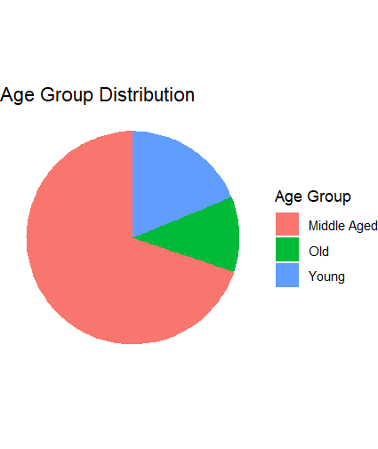
Fig1 : Pie Chart of Age Groups

#2. Scatter plot: Quantity vs Age
ggplot(dataset, aes(x = age, y = quantity)) +
geom_point(alpha = 0.5) +
labs(
title = "Quantity vs Age",
x = "Age",
y = "Quantity"
) +
theme_minimal()
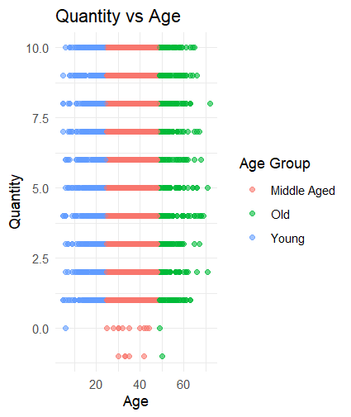
Fig2 : Scatter Plot - Quantity vs Age Comparison

Descriptive Statistical Analysis:

- Age Group Distribution:

1.1 This pie chart displays the Age Group Distribution in the dataset. The three segments represent Young (5–24), Middle Aged (25–48), and Old (49–72) customers, with segment size proportional to the number of customers or orders in each group. We can say from the chart that :
• The Middle Aged group occupies more than half of the pie, indicating that most customers fall within the 25–48 age range, which is 69.8%.
• The Young group forms a noticeable but smaller portion of the pie, showing that younger customers represent a moderate share of the customer base, which is 18.8%.
• The Old group is the smallest segment, suggesting that older customers account for the lowest proportion of observations in the dataset, which is 11.4%.

  - Central Tendency :
• Because the Middle Aged segment dominates the pie chart, the typical customer in this dataset is likely in their late twenties to late forties.

The presence of both Young and Old segments shows that the dataset includes a wide age range, but the concentration is clearly around middle age.

1.3 Interpretation for Business Analysis and decision making :
From a retail perspective, the age group distribution suggests that middle-aged customers are the primary target audience, as they generate the majority of orders or transactions in the dataset.

This indicates that the dataset is dominated by middle-aged individuals, suggesting that they are the main contributors to retail activity in this sample, with younger and older customers playing secondary roles.

- Scatter Plot Analysis:

2.1 This scatter plot shows the relationship between Age (x-axis) and Quantity purchased (y-axis) for three age groups: Young (5–24), Middle Aged (25–48), and Old (49–72). Each point represents one order, colored by age group. So the following trend looks like this :

Overall, quantity values appear fairly similar across ages; there is no strong increasing or decreasing trend of quantity with age visible in the scatter plot.

Lower quantities (0–3 units) include customers from all age groups, but higher quantities (8–10 units) seem slightly more common among Middle Aged and Old customers than among Young customers.

  - Central tendency:

Young customers mostly purchase small to medium quantities, with points concentrated between 1 and 7 units. Their purchases cover a wide age range within the Young category, but few very high quantities appear.
Middle-aged customers show frequent purchases across the full quantity range, including higher quantities close to 10 units. This suggests that middle-aged customers may buy slightly more items on average than young customers.

Old customers also buy across the quantity range, and the plot shows many points at medium and high quantities, indicating that older customers are active buyers and may have similar or slightly higher quantities compared to the middle-aged group.

